VISVESVARAYA TECHNOLOGICAL UNIVERSITY
JnanaSangama, Belagavi- 590 018

SYNOPSIS ON
“LLM-Driven Financial Chatbot for Real-Time Stock Market Analysis”

submitted by
Amaan Siddiqui: 1DB23CS012
Achuta Rao M: 1DB23CS004
Shreejal Dash: 1DB23CS201
Kishan Kumar : 1DB23CS103

Under the guidance of
Mrs. Anjali Vyas
(Assistant Professor)
Dept of CSE



Wayanamac Education Trust®

DON BOSCO INSTITUTE OF TECHNOLOGY
Kumbalagodu, Mysuru Road, Bengaluru – 560074
(An Autonomous Institution under VTU, Accredited by NBA & NAAC with ‘A’ Grade
Approved by AICTE, New Delhi, Recognized by Govt. of Karnataka)
Department of Computer Science & Engineering
2025-2026

Table of Content
Sl .No | Chapter | Pg No.
 | Abstract
 | Introduction, Problem Statement and Objectives | 1-3
 | Literature Survey | 4
 | Proposed Model | 5-6
 | System Design and Architecture | 7-9
 | References | 10

Abstract :
With over 130 million registered retail investor accounts in India and a growing number of uninformed trading losses among first-time market participants, there is an increasing need for accessible and intelligent financial guidance systems. Many retail investors lack the analytical tools and financial expertise required to interpret complex market signals, resulting in poor investment decisions and higher financial risk. This highlights the importance of developing scalable solutions that can assist investors in understanding market conditions and making informed decisions.

This proposed idea FinSight AI, a web-based financial assistant with an AI-powered conversational interface that analyzes real-time market information and investor sentiment to generate meaningful investment insights. The system aims to simplify financial analysis by presenting complex market information in an understandable form, enabling users to evaluate stocks, SIP options, and investment opportunities more effectively. By combining intelligent analysis with a user-friendly interface, FinSight AI seeks to improve financial accessibility and support better investment decision-making for retail investors who lack access to professional advisory services.

Introduction :
In recent years, the Indian stock market has witnessed a significant increase in retail investor participation due to the accessibility of digital trading platforms and mobile investment applications. According to recent reports, India has a numerous retail investor accounts, indicating rapid growth in market participation. However, a large number of new investors lack sufficient financial knowledge and analytical tools, which often leads to uninformed investment decisions and financial losses.
Traditional market analysis tools mainly focus on numerical market data and technical indicators, which do not fully capture real-time investor sentiment and qualitative information available on online platforms such as financial news websites and social media communities.
Recent advancements in Artificial Intelligence (AI), Machine Learning (ML), and Large Language Models (LLMs) provide new opportunities to analyze both structured financial data and unstructured textual information. These technologies enable the development of intelligent systems that can interpret complex market signals, generate investment insights, and interact with users through natural language interfaces.The proposed FinSight AI, a full-stack conversational investment assistant designed to provide real-time market intelligence and personalized financial insights. The system integrates live stock market data from NSE and BSE, sentiment analysis from Reddit communities and financial news sources, and IPO market indicators such as Grey Market Premium (GMP). Using Google Gemini 1.5 Flash combined with a Retrieval-Augmented Generation (RAG) framework powered by ChromaDB.
1

The system generates actionable insights including stock buy/sell signals, SIP fund suggestions, and IPO investment assessments.
Additionally, the platform incorporates a paper trading simulation module, allowing users to test investment strategies using virtual capital without financial risk. The system is deployed as a React-based web application with a FastAPI backend, enabling users to interact with the platform through a conversational interface and receive understandable financial guidance. The primary goal of the system is to assist retail investors in making more informed investment decisions through AI-driven analysis and real-time market insights.

Problem Statement:
Retail investors in India often incur financial losses due to the absence of intelligent tools that interpret market data and sentiment in real time. Most existing trading platforms provide raw financial information but lack systems that combine market data, news sentiment, and AI-driven insights to support informed investment decisions.

2
Objectives :
The primary objective of the proposed idea is to develop FinSight AI, an intelligent conversational investment assistant that provides real-time financial insights and investment guidance using artificial intelligence and machine learning techniques.

The specific objectives of the project are as follows:

- To collect and integrate real-time stock market data from major Indian stock exchanges such as NSE and BSE for analyzing market trends and price movements
- To develop an AI-based system capable of generating stock investment insights, including buy, hold, or sell signals based on market data and sentiment analysis.
- To design an intelligent recommendation system that can suggest suitable SIP investment options and evaluate IPO opportunities using available market indicators such as Grey Market Premium.

3
Literature Survey :

Title of Paper | Authors | Journal | Year | Methodology | Limitation
MARAG-Fin: Intelligent Multi-agent RAG-LLM... | M. Luckianto et al. | Int. J. Intell. Eng. Syst. | 2026 | Multi-agent RAG with NeuralProphet for index forecasting. | High latency in real-time agent coordination.
Order-Aware Multimodal Fusion for Advisory... | S. Das et al. | IEEE Access | 2025 | Transformer-based fusion of video and financial text. | Focuses on summary quality, not price prediction.
Hybrid LSTM with Sentiment Analysis System... | K. Liagkouras et al. | Electronics (MDPI) | 2025 | Fuses LSTM with news sentiment for directional prediction. | Limited to regulatory news; lacks social media "noise."
LLMs in Equity Markets: Applications & Insights | A. Jadhav et al. | Front. Artif. Intell. | 2025 | Review of LLM techniques for portfolio and risk research. | Highlights LLM "Black Box" and interpretability issues.
Using LLMs to Predict Stock Price: Hybrid Model | N. Srivatsan | Natl. High Sch. J. Sci. | 2025 | Combined Zero-Shot sentiment with LSTM and XGBoost. | Accuracy depends solely on high social media volume.

4
Proposed Model :

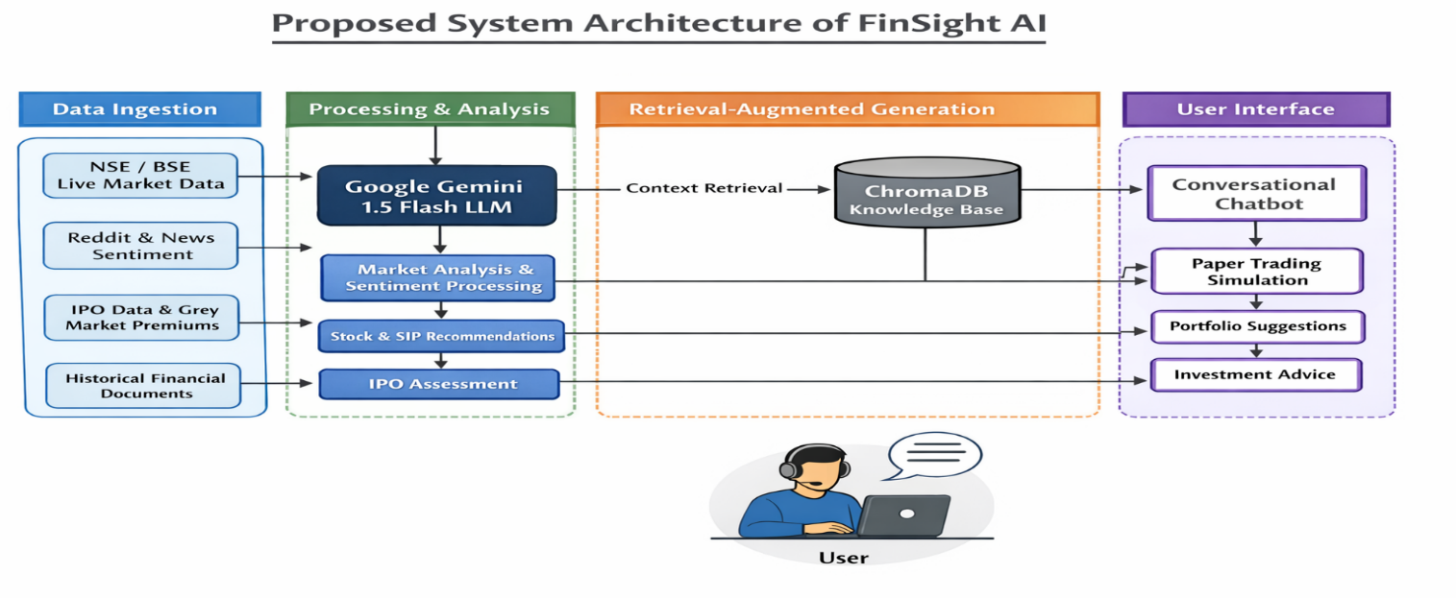
1. Presentation Layer (Top Layer - What the User Sees)
- Component 1: A box labeled "React.js Web Application".
  - Sub-elements within this box: User Dashboard (Stock Charts), Conversational Chat Interface, Paper Trading Portfolio View.
- Data Flow: A double-headed arrow labeled "HTTPS / JSON" connecting down to the next layer.
2. Service Layer (Second Layer - The "Brain")
- Component 1: A large box labeled "FastAPI Backend Server (Python)".
  - Sub-elements within this box (Key Agents):
    - Orchestrator Agent: The central coordinator that decides what data is needed.

5
    - Recommendation Engine: Logic to combine sentiment and technical data into signals (SIP/Buy/Sell).
    - Paper Trading Module: Handles virtual transactions using SQLite.
- Data Flow: Arrows pointing from the Orchestrator to the "LLM & RAG Layer" below it.
3. LLM & RAG Layer (Third Layer - The "Reasoning")
- Component 1: A box labeled "Gemini 1.5 Flash API" (The core inference engine).
- Component 2: A box labeled "Vector Database (ChromaDB)".
  - Content within this box: DRHP Prospectuses, Financial Documents, SEBI Circulars (as Embeddings).
- Data Flow: An arrow labeled "Augmented Context" pointing from ChromaDB to Gemini. Gemini then sends reasoned text back up to the FastAPI layer.
4. Data Ingestion Layer (Bottom Layer - The "Eyes")
- Component 1 (Quant Data): A circle/cylinder labeled "yfinance API" and "nsepython Scraper" (Real-time Equity Prices, NIFTY 50).
- Component 2 (Qualitative Data): A circle/cylinder labeled "Reddit API (PRAW)" and "Chittorgarh Scraper" (Sentiment from r/IndiaInvestments, IPO GMP).

6

System Design and Architecture :
- FinSight AI follows a Decoupled Three-Tier Architecture integrated with a Multi-Agent RAG (Retrieval-Augmented Generation) framework. This design ensures separation of concerns between the user interface, backend logic, and the high-latency AI/Data ingestion processes.
1. System Layers & Components
A. Presentation Layer (Frontend)
- Built with React.js, this layer manages the user experience and state. It is designed to be lightweight, delegating all heavy computations to the backend.
- Live Dashboard: Visualizes real-time stock trends using high-performance charting libraries (e.g., ApexCharts or Recharts).
- Conversational Interface: A chat-based UI that handles natural language queries and displays "Agentic Reasoning" steps to the user.
- Paper Trading Module: A dedicated view for tracking virtual capital, portfolio performance, and historical "virtual" trades.
B. Application Layer (Backend)
- The core logic resides in a FastAPI server, chosen for its asynchronous capabilities which are critical for handling concurrent API calls to Gemini and NSE.
7
- Agentic Orchestrator: This is the "Brain" that coordinates between the user's intent and available tools. It decides whether to fetch live prices, scrape Reddit, or retrieve data from the Knowledge Base.
- Trading Logic Engine: Handles the mathematical simulation of paper trading, including profit/loss calculation and portfolio rebalancing.
- API Gateway: Manages secure communication between the React frontend and internal services.
C. Intelligence & RAG Layer
- This layer transforms raw data into actionable advice using LLM.
- Gemini 1.5 Flash: Acts as the primary inference engine, processing multi-source context (news + prices + tweets) to generate structured financial assessments.
- ChromaDB (Vector Database): Stores high-dimensional "embeddings" of financial documents (RHPs, SEBI guidelines). It allows the system to perform Semantic Search to ground AI responses in factual, historical documents.
2. Data Flow Architecture
- The system employs a Hybrid Data Ingestion strategy to maintain a real-time edge:
- Quantitative Stream: Uses python and yfinance to pull live LTP (Last Traded Price), OHLC data, and corporate actions directly from the exchanges.
8
- Qualitative Stream: A background worker scrapes Reddit (r/IndiaInvestments) and IPO news sites using PRAW and BeautifulSoup.
- Knowledge Stream: Static financial PDFs are pre-processed, chunked, and stored in ChromaDB during the system setup phase.
3. Key Design Patterns
- Agentic Tool-Use Pattern: The LLM is given access to specific Python functions to fetch data. It only speaks once it has gathered enough evidence.
- Asynchronous Pattern: Non-blocking calls are used for data scraping and LLM generation to ensure the UI remains responsive.
- Singleton Pattern: Used for database connections ChromaDB and SQLite to optimize resource usage.

9
References :
[1] M. Luckianto and A. A. S. Gunawan, "MARAG-Fin: An Intelligent Multi-agent RAG-LLM Architecture Integrating Financial News Sentiment and Time Series Data for Data-driven Trading Decision-making," Int. J. Intell. Eng. Syst., vol. 19, no. 1, pp. 738-748, 2026.
[2] S. Das, S. Ghosh, A. Tiwari, R. E. Z. M. Lynghoi, S. Saha, Z. Murad, and A. Maurya, "Presenting an Order-Aware Multimodal Fusion Framework for Financial Advisory Summarization With an Exclusive Video Dataset," IEEE Access, vol. 13, pp. 48364-48381, 2025
[3] K. Liagkouras and K. Metaxiotis, "A Hybrid Long Short-Term Memory with a Sentiment Analysis System for Stock Market Forecasting," Electronics, vol. 14, no. 2753, pp. 1-18, 2025
[4] A. Jadhav and V. Mirza, "Large Language Models in equity markets: applications, techniques, and insights," Front. Artif. Intell., vol. 8, no. 1608365, pp. 1-15, Aug. 2025
[5] N. Srivatsan, "Using Large Language Models to Predict Stock Price: A Hybrid Model Combining Social Media Sentiment and Market Data," Natl. High Sch. J. Sci., pp. 1-12, Aug. 2025.

Guide Signature HoD Signature
Project Batch Number: 60
10

